**Hydrogel as a strategy in stroke injury treatment**

**Department of CIBIO, Quantitative and Computational Biology**

**Tissue Engineering, prof A. Motta**

**V. Facchinelli, A. Gagliardi, A. Santo, R. Slatni**

**Introduction to stroke and inflammatory context**

A stroke is a dramatic event that occurs when an artery in the brain is blocked (ischemic) or ruptures (hemorrhagic) resulting in death of an area of brain tissue due to loss of its blood supply. The damage that results depends on how long brain cells are deprived of blood. If they are deprived for only a brief time, brain cells are stressed, but they may recover. If brain cells are deprived longer, brain cells die, and some functions may be lost, sometimes permanently.

The acute phase of stroke is driven by an intense neuroinflammation that cause BBB breakdown, vasogenic edema and neuronal injury, instead the post-ischemic inflammation in late stages could promote recovery by facilitating neurogenesis, angiogenesis, and neuronal plasticity. The concept of neurovascular unit comprehends all the cells phenotype at the level of BBB and their interactions: brain endothelial cells, astrocytes, pericytes, nerve terminals, microglia, and perivascular macrophages. The disruption of BBB is a crucial step since leads to a sequence of event that contribute to the increase of local inflammation and damage, including: oxidative stress, MMPs (matrix metalloproteinases), microglial activation, and peripheral immune cell invasion into the ischemic tissue.

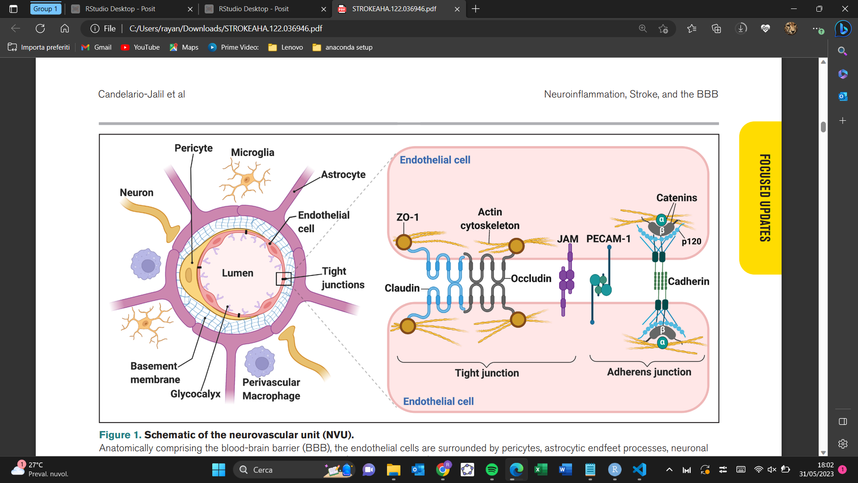

Fig1. Representation of the main components in the BBB [1]

After a stroke the blood flow needs to be quickly restored, the sudden re-exposure to oxygen contributes to the formation of reactive oxygen species (e.g. superoxide radical O2 −) leading to oxidative stress and contributing to cell damage at the level of tight-junctions in the BBB, resulting in loss of integrity of BBB. At the same time the MMPs are activated by neuroinflammatory cytokines contributing to the degradation of the basal lamina and TJPs (tight junction protein).

Dying brain cells release many molecules that activate immune cells through the engagement of PRRs (pattern recognition receptors) such as the TLR (toll-like receptor) that induce the family the secretion of proinflammatory cytokines by innate immune cells. These events trigger proinflammatory intracellular signaling cascades and transcription factors, for example, NF-κB (nuclear factor kappa B), ROS, MMPs, and the release of proinflammatory cytokines, especially IL-1β, IL-6, IL-17, IL-18, and TNF (tumor necrosis factor)-α, to initiate a local sterile immune response, which is associated with BBB dysfunction after stroke. The first cells to respond are microglia—the brain’s resident immune cells. Activated microglia migrate to the injured area and release proinflammatory cytokines, NO, ROS, prostaglandins, and chemokines, resulting in the additional chemoattraction of circulating macrophages, neutrophils and leukocytes. In particular T regulatory (Treg) cells arrive several days after brain ischemia but are still present >30 days post-lesion. T cells play a significant role in secondary neuroinflammation and stroke outcome. [1]

**Angiogenesis in stroke**

During the pathophysiological process of stroke, angiogenesis serves as a crucial protective mechanism, facilitating brain regeneration and functional recovery.

Studies have shown that 3–4 days after the stroke occurs, new blood vessels start sprouting in the area surrounding the damage, originating from pre-existing blood vessels. This intricate process is orchestrated by numerous pro-angiogenic factors, including growth factors and cytokines, that collaborate during the four stages of sprouting: endothelial cell migration, tissue remodeling, differentiation, and lumen formation. The new microvascular network formation also promotes macrophage infiltration and clearance of necrotic tissue.

The process starts with the degradation of the endothelial matrix (ECM) which involves proteases and angiogenic cytokines like VEGF, Ang1, Ang2, and αvβ3 integrin.

Endothelial network maturation involves survival, differentiation, and vascular remodeling. Growth factors include bFGF, NGF, PDGF, BDNF, TGF-β1, and VEGF-A, the most potent growth factor for angiogenesis after ischemic stroke in adults. HIF-1 and HIF-2 increase VEGF expression through ischemia or hypoxia, while PGC-1 regulates VEGF expression and hindlimb angiogenesis. Cytokines involved in angiogenesis are IL-8, IL-6, TNF-α, and TSLP.

The timing and extent of angiogenesis after an ischemic stroke can vary among individuals where factors such as age, health and severity of the stroke can influence the speed and effectiveness of this process. However, stroke patients exhibiting higher cerebral blood vessel density demonstrate improved survival rates. As a result, inducing angiogenesis in the peri-infarct region can significantly boost hemodynamics, promote vascular remodeling, and contribute to the restoration of neurovascular function after an ischemic stroke. [2][3]

**Stem cells involved in angiogenesis and brain healing**

Moreover, it has been demonstrated that different stem and progenitor cells can participate in this process having beneficial effects. Circulating endothelial progenitor cells (EPCs) are potential biomarkers for diagnosing and prognosing cerebral ischemia. They differentiate into functional ECs, promoting angiogenesis and improving cerebral ischemic injury.

Bone marrow stromal cells (BMSCs), can cross the blood-brain barrier, promoting angiogenesis and remodeling in ischemic stroke.

Another important type of stem cells are NSCs (Neural stem cells proliferate) which migrate and differentiate into neurons and astrocytes in the hippocampus and cerebral cortex during ischemic brain injury. However, the level of proliferation and migration induced by stroke is insufficient to promote repair, as a large number of these newborn cells die before they can mature and integrate into the neuronal network.

Mesenchymal stem cells (MSCs) are among the most widely studied multipotent stem cells. Their capability of differentiation into almost any end-stage lineage cells and strong paracrine effects make MSCs a promising candidate for endogenous regeneration. The choice of MSC source, including the bone marrow (BM), adipose tissue (AT), and umbilical cord blood (UCB), is critical in determining the therapeutic potential of MSCs.

Studies show that intravenous administration of MSCs or the human MSC cell line B10 can improve functional recovery and transfer functional mitochondria to stroke-injured ECs via nanotubes, improving endothelial cell function and saving the cerebrovascular system. [3]

It is shown that AT-MSCs produce a significantly larger amount of cytokines and growth factors, which mediate paracrine actions that promote cellular survival pathways and tissue-repair mechanisms, so these cells are best suited for regeneration.

Stem or progenitor cells transplantation after stroke was shown to promote recovery in pre-clinical models, and their therapeutic effects were attributed to the secretion of factors which reduce levels of axonal growth inhibitors and promote growth and neurogenesis.

However, these studies are limited by poor survival of the transplant when administered as a suspended form into the damaged brain due to the immunological attack and the lack of a structure in which to grow.

**Biomaterials for CNS**

The application of biomaterials in ischemic strokes is aimed at either delivering MSCs and therapeutic drugs, and functioning as an extracellular matrix suitable for brain tissue growth. The biomaterial must be biocompatible but also bioresorbable to allow transplanted cells to degrade the biomaterials as they spread within the gel, form a network and migrate towards the peri-ischemic area where they can connect an existing network. Recent studies showed that the transplantation of MSCs in a functionalized self-assembling peptide hydrogel into the ischemic injury facilitated the structural recovery of the neural tissue and improved neurological function. Hydrogels, hydrophilic polymer systems capable of retaining substantial water within their architectures, can transport cells, drugs, proteins, and aid in tissue repair. Hydrogels with a biomimetic structure resembling the extracellular matrix (ECM) have gained attention as 3D scaffolds for central nervous system (CNS) regeneration. In particular, injectable hydrogels offer minimal invasiveness and can imitate various aspects of the CNS. They hold promise as therapeutic agents by mimicking CNS properties, reducing subsequent injuries, and facilitating neural tissue regeneration. The more challenging issue in tissue repair is that CNS damage is characterized by secondary injury cascades, including neuro-inflammation, glial scar formation, and neurodegeneration. Accumulation of cellular debris in the injured area hinders the healing process. Modulating the inflammatory environment following damage is crucial for effective regeneration. Glial scar formation poses a major challenge to CNS tissue repair, as it impedes axonal penetration and regeneration.

The ideal hydrogel should simulate the soft tissue architecture, chemical/mechanical properties and topography, prevent glial scarring-induced damage, promote neurite regeneration, facilitate cell colonization, and repair injured blood vessels.

Pore size is also a critical feature that influences cell attachment, migration, diffusion of medium and metabolites, as well as cell survival, organization, and differentiation. The appropriate range for neural cell growth is a pore size of 10 to 100 μm with 90% scaffold porosity.

Also the scaffold's mechanical properties must match the natural stiffness of the CNS to facilitate cell attachment, migration, and differentiation. However, excessive stiffness may inhibit axon elongation and neural cell regeneration. Conductivity and bioelectrical stimulation ability are also important factors for neural tissue engineering. Electrically conductive materials, such as conducting polymers (e.g., polyaniline, polypyrrole) and carbon-based materials (e.g., carbon nanofibers, carbon nanotubes, graphene), can facilitate neural cell communication and electrical signal transmission.

Finally, the gelation time of injectable hydrogels is crucial to ensure proper injection. It should occur quickly enough to retain the hydrogel and any therapeutic agents at the injection site, while the degradation rate must strike a balance between early degradation, which affects glial scarring and axon elongation, and late degradation, which promotes tissue generation and prevents long-distance axonal regeneration.

Similarly, in other studies, a functionalized self-assembling peptide hydrogel was shown to reduce the formation of the glial scar after stroke.

For these reasons we used Gelatin methacrylate (GelMA) , a self-assembling peptide hydrogel. Gelatin itself is obtained from the denatured collagen, a naturally made protein found in the extracellular matrix; this makes the material biocompatible and biodegradable for cell growth. In the presence of methacrylate, GelMA can be crosslinked via photo-polymerization. To improve the efficiency of the material, the cross-linking of GelMA leading to the formation of the hydrogel will be carried out once the hydrogel is injected.

In the context of drug delivery, different functionalized molecules were previously shown to penetrate through the ischemic cortex and reach the damaged tissue when delivered epicortically from GelMA hydrogel. However, protein delivery from a hydrogel scaffold is governed by Fickian diffusion and tends to occur rapidly. The sustained release over a minimum of 2 weeks, which is required for CNS tissue repair, cannot be easily achieved from a hydrogel alone.

In this assay we discuss how a composite system that allows sustained release of different drugs at different times is favorable. This can be achieved by encapsulating each of the molecules in polymeric (PLGA) nanoparticles and incorporating the particles into the hydrogel.

**Laboratory: construction of a scaffold for stroke repair**

We developed a scaffold based on hydrogel enhanced with nano-particles without functionalized cells or drugs.

**Material**

1. Lemon essential oil -> 380 μL
2. Surfactants: we use two different surfactants (one for water and one for oil it depends on the hydrophilicitys degree):

* TWEEN 80 -> 20 μL
* PVA 1,1% colored with phenol red (pH indicator) - 0,022 mL

1. Water
2. Micropipettes
3. UV lamp
4. Gelatin methacrylate

**Methods**

1. Create an emulsion: first we mixed 380 μL of lemon essential oil with 20 μL of TWEEN 80, then, in a different test tube, we mixed PVA (1.1%) with water in a 2 mL solution. We obtained an oil-in-water emulsion by dropping small drops of oil in water and mixing everything well mechanically using a vortex (30s at 40hz (x3) for a stable emulsion). At the end of the process the oily phase should be dispersed in water forming fine stable droplets.
2. Build the hydrogel: we incorporate the nanoparticles obtained in the first step with a methacrylate gelatin containing LAP (0.5%) as a photoinitiator. LAP has been solved in water as 4% of the total volume and then incorporated in the gelatin.

For the design of the right hydrogel we tested out 3 different concentrations of our compound in gelatin for a total volume of 300 μL.

| Trial | Oil-in-water emulsion (μL) | Gelatin (μL) | Total volume (μL) |
| --- | --- | --- | --- |
| A | 150 | 150 | 300 |
| B | 100 | 200 | 300 |
| C | 50 | 250 | 300 |

1. Casting and gelification: the gelification of our compound occurred by Photopolymerization. Photopolymerisation or photocrosslinking begins with the photoinitiator, LAP in this case, which is cleaved to form free radicals that initiate a polymerisation reaction that forms cross-links between the methacrylate residues. 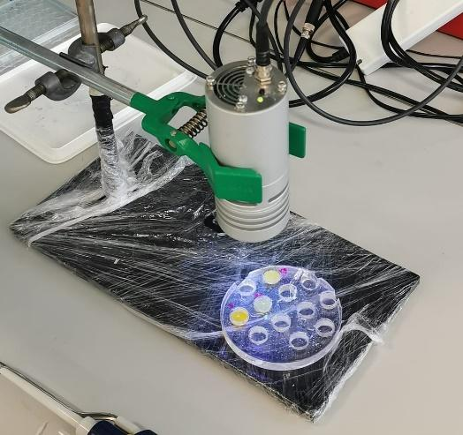

The LAP photoinitiator, in addition to initiating the reaction, also serves to refine the photocrosslinking experiment (i.e. altering hydrogel stiffness or gelling speeds).

The 3 different mixtures A, B and C were first placed in small round containers and then photocrosslinked by leaving them under UV light for 1 minute.

1. Nanoparticles release and H2O resistance:

After gelling, we assessed whether the properties of the three discs could be compared to those of a hydrogel. We tested their behavior in water by focusing on their solubility rate and stiffness and it turned out that only compounds B and C had the properties of a hydrogel, i.e. those compounds with a higher percentage of gelatin.

The trial number one, A, on the opposite, does not possess the properties of a hydrogel because of its low gelatin content.

In fact, the mechanical properties of the hydrogel are given by the network bonds that are created in the gelatin after the photopolymerization treatment due to its composition, therefore, the stiffness and porosity of the material depends mainly on the percentage of methacrylated gelatin.

We chose C as our hydrogel (1/6 nanoparticles – 5/6 gelatin).

*Figura 2: “C” had all the properties of a hydrogel, the right rigidity and a reduced disintegration rate in water, resulting in greater stability and, in terms of application, in a slow and controlled release of nanoparticles. B is also a hydrogel but with a higher release rate while A lacks the properties of a hydrogel due to its low gelatin content.*

1. Injectable hydrogel:

Finally, we tested whether our hydrogel was injectable.

In order to do this, we recreated the "C" pre-hydrogel solution, as shown in the table, and placed it into a syringe at room temperature. Then we put the syringe in a freezer at 4°C for 10 minutes until we get a high-viscosity compound.

This type of technique is called physical cross-linking, in fact it uses temperature to compact the gelatin creating new cross-links that make the compound rigid. This reaction is reversible until blocked with a chemical-crosslinking.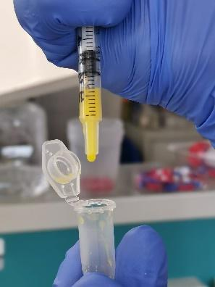

Fortunately the hydrogel we chose was injectable and retained its shape after chemical crosslinking.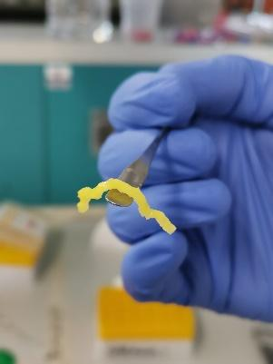

In conclusion, we succeeded in creating a methacrylated gelatin hydrogel able to release lemon essential oil based nanoparticles in the environment. Moreover gelatin derived from denatured collagen retains many natural cell binding motifs such as RGD and MMP sites (Cell-adhesion peptides). [16]

On the other hand, lemon-essential-oil based nanoparticles are affordable, easy to prepare and retain LEO known for its neuroprotective and anti-microbial properties. [17][18]

**Scaffold functionalization with growth factors**

Biomaterials are even promising drug delivery vehicles for their ability to provide local, time-controlled release, which is particularly important in the brain since the BBB imposes intravenous drug delivery restrictions. For the administration of drugs, nanoparticles (submicron-sized particles) prove to be the best choice since they can be functionalized with therapeutic agents and targeted to specific cells or tissues. The size of the stroke lesion and the timing of administration can also impact the rate at which therapeutic agents need to be released, and to control the release we need to control particle size. Larger lesions may require sustained drug release over a longer period, and therefore larger nanoparticles.

Growth factors are important to create a pro-regenerative environment. Some of the factors include erythropoietin (EPO), BDNF, fibroblast growth factor (FGF), and vascular endothelial growth factor (VEGF). In particular Vascular endothelial growth factor (VEGF, VEGFA) is critical for blood vessel growth in the developing and adult nervous system of vertebrates, it promotes neurogenesis, neuronal patterning, neuroprotection and glial growth.

In situ injectable hydrogels are a promising type of drug delivery system, and they can promote repair through providing structural support to the surrounding tissue to minimize secondary cell death and manage the inflammatory response, and serve as a cell transplantation vehicle.

In order to find the best drug to insert into nanoparticles, we analyzed the most recent documentation on it, and it was seen that the delivery of erythropoietin in uninjured and stroke-injured brains resulted in an attenuated inflammatory response, reduced stroke cavity size, and increased neurogenesis. The delivery of epidermal growth factor (EGF) increased the proliferation of neural progenitor cells (NPCs) along the ventricles and in the hippocampus, while modifying EGF with polyethylene glycol (PEG) significantly enhanced protein stability, diffusion distance, and in vivo bioactivity. The delivery of vascular endothelial growth factor (VEGF) to the stroke cavity encapsulated in nanoparticles showed increased MSCs differentiation towards astrocytes and neurons and an enhanced revascularization of the stroke area. It is even shown that it is important to maintain elevated tissue levels of VEGF in the stroke site for prolonged periods of time to improve tissue regeneration.

Sequential delivery of EPO, VEGF and EDF-PEG by encapsulation of these factors in nanoparticles, subsequent delivery within the hydrogel and injection in the stroke cavity should lead to reduced inflammation, and significantly improved neurogenesis.

**Further improvement for the hydrogel**

The interactions between implanted hydrogel and endogenous brain cells have the potential to induce many different reparative and anti-inflammatory cellular pathways, through binding of Cell-adhesion peptides (CAPs) to specific cell surface receptors, which can be used to functionalize the scaffold. Anti-inflammatory targets of CAPs include cell adhesion molecules (CAMs), which are involved in the recruitment and trafficking of leukocytes; integrin receptors, which have anti-inflammatory effects and proangiogenic properties, and promote the infiltration of neural progenitor cells to the site of injury; growth factor receptors that can initiate similar anti-inflammatory effects.

**Conclusions**

In order to circumvent the highly selective BBB, a hydrogel has been uploaded with bioactive molecules with the aim of a direct implantation into the brain. This approach reduces the dose that is needed to produce positive effects and decrease the toxicity associated with systemic approaches that usually require higher doses of drugs. Although different biomaterials and formats can be implanted in the brain, thereby extending drug activities, their biocompatibility and integration with host tissue still constitutes an important concern that needs to be resolved. Overall the combination of hydrogels, nanoparticles and active molecules might ensure a less invasive strategy for local drug delivery while maintaining temporal controlled release.

References

1. Eduardo Candelario-Jalil, Neuroinflammation, Stroke, Blood-Brain Barrier Dysfunction, and Imaging Modalities, 7 Apr 2022, [doi.org/10.1161/STROKEAHA.122.03694](https://doi.org/10.1161/STROKEAHA.122.036946)6
2. Jinwei Pang , Nathanael Matei, Macrophage Infiltration Reduces Neurodegeneration and Improves Stroke Recovery after Delayed Recanalization in Rats, Oxidative Medicine and Cellular Longevity Volume 2022, Article ID 6422202, 18 pages, doi.org/10.1155/2022/6422202
3. Jie Fang, Zhi Wang and Chao-yu Miao, Angiogenesis after ischemic stroke, Acta Pharmacologica Sinica (2023) 0:1–17, doi.org/10.1038/s41401-023-01061-2
4. E. Hasanzadeh et al. / Materials Today Bio 20 (2023). Injectable hydrogels in central nervous system: Unique and novel platforms for promoting extracellular matrix remodeling and tissue engineering*.*
5. Y. Wang et al. / Journal of Controlled Release 172 (2013) 1–11
6. K. Jin, X. Wang, L. Xie, X.O. Mao, W. Zhu, Y. Wang, J. Shen, Y. Mao, S. Banwait, D.A. Greenberg, Evidence for stroke-induced neurogenesis in the human brain, Proc. Natl. Acad. Sci. U. S. A. 103 (2006) 13198–13202.
7. A. Arvidsson, T. Collin, D. Kirik, Z. Kokaia, O. Lindvall, Neuronal replacement from endogenous precursors in the adult brain after stroke, Nat. Med. 8 (2002) 963–970.
8. D.N.Abrous, M.Koehl, M.LeMoal, Adult neurogenesis: from precursors to network and physiology, Physiol. Rev. 85 (2005) 523–569.
9. R.J. Felling, S.W. Levison, Enhanced neurogenesis following stroke, J. Neurosci. Res. 73 (2003) 277–283.
10. R.J. Lichtenwalner, J.M. Parent, Adult neurogenesis and the ischemic forebrain, J. Cereb. Blood Flow Metab. 26 (2006) 1–20.
11. Hydrogels for brain repair after stroke: an emerging treatment option Lina R. Nih1 , S. Thomas Carmichael2 , Tatiana Segura1,* 1 Chemical and Biomolecular Engineering and 2 Neurology Department, University of California, Los Angeles.
12. Bai, Y.; Han, B.; Zhang, Y.; Zhang, Y.; Cai, Y.; Shen, L.; Jia, Y. Advancements in Hydrogel Application for Ischemic Stroke Therapy. Gels 2022, 8, 777, [doi.org/10.3390/gels812077](https://doi.org/10.3390/gels8120777)7
13. Zamproni LN, Mundim MTVV, Porcionatto MA. Neurorepair and Regeneration of the Brain: A Decade of Bioscaffolds and Engineered Microtissue. Front Cell Dev Biol. 2021 Apr 7;9:649891. doi: 10.3389/fcell.2021.649891. PMID: 33898443; PMCID: PMC8058361.
14. Julian George, Chia-Chen Hsu, Linh Thuy Ba Nguyen, Hua Ye, Zhanfeng Cui,Neural tissue engineering with structured hydrogels in CNS models and therapies,Biotechnology Advances,Volume 42,2020,107370.
15. Rajkovic Olivera, Potjewyd Geoffrey, Pinteaux Emmanuel, Regenerative Medicine Therapies for Targeting Neuroinflammation After Stroke, Frontiers in Neurology,9,2018, doi[/10.3389/fneur.2018.00734](https://www.frontiersin.org/articles/10.3389/fneur.2018.00734).
16. (<https://www.sigmaaldrich.com/IT/it/product/mm/cc3242>)
17. (Soltanzadeh M, Peighambardoust SH, Ghanbarzadeh B, Mohammadi M, Lorenzo JM. Chitosan nanoparticles encapsulating lemongrass (Cymbopogon commutatus) essential oil: Physicochemical, structural, antimicrobial and in-vitro release properties. Int J Biol Macromol. 2021 Dec 1;192:1084-1097. doi: 10.1016/j.ijbiomac.2021.10.070. Epub 2021 Oct 19. PMID: 34673101.)
18. .Eddin LB, Jha NK, Meeran MFN, Kesari KK, Beiram R, Ojha S. Neuroprotective Potential of Limonene and Limonene Containing Natural Products. Molecules. 2021 Jul 27;26(15):4535. doi: 10.3390/molecules26154535. PMID: 34361686; PMCID: PMC8348102.